**Looking for roughening conditions**

**Run 1**. This run went “unstable,” with roughening on a horizontal scale of . The corner supersaturation is small, at . The vertical relief of corresponds to (), so not visible on an SEM image – hence “incipient roughening.”

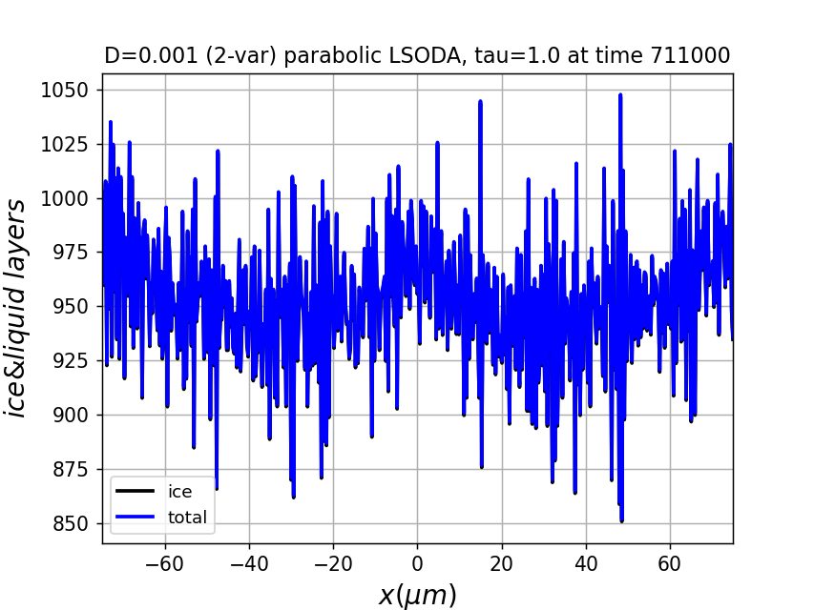

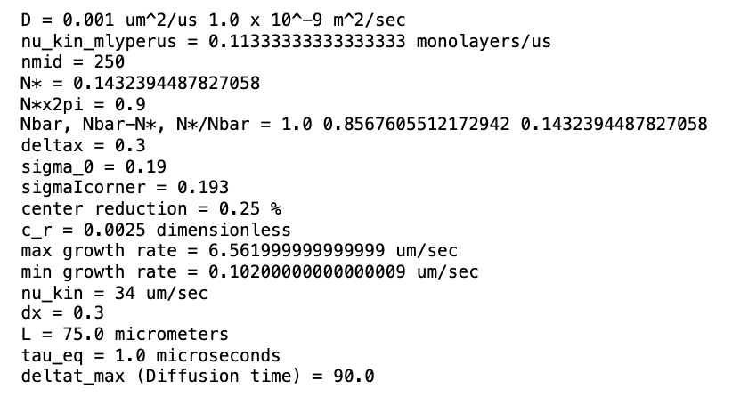

**Run 2**. Can **higher supersaturation** avoid the instability shown in Run 1? The answer is Yes, when (as shown below) the corner supersaturation is increased to .

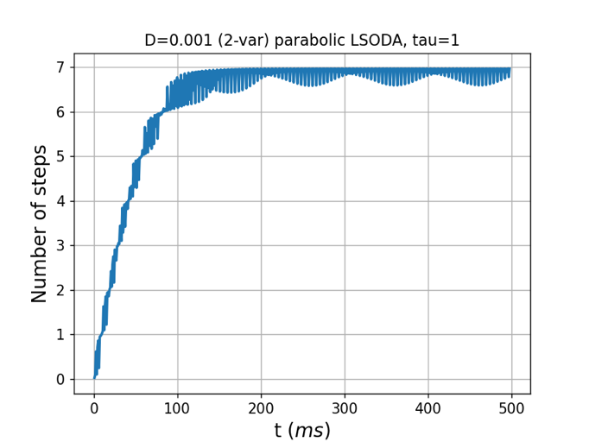 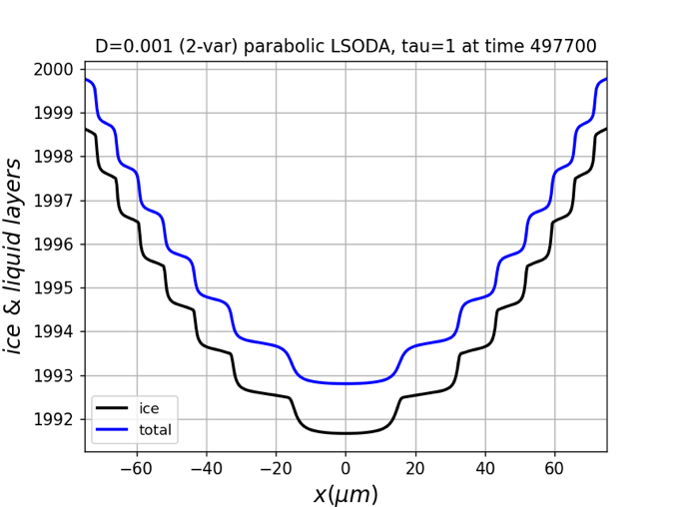

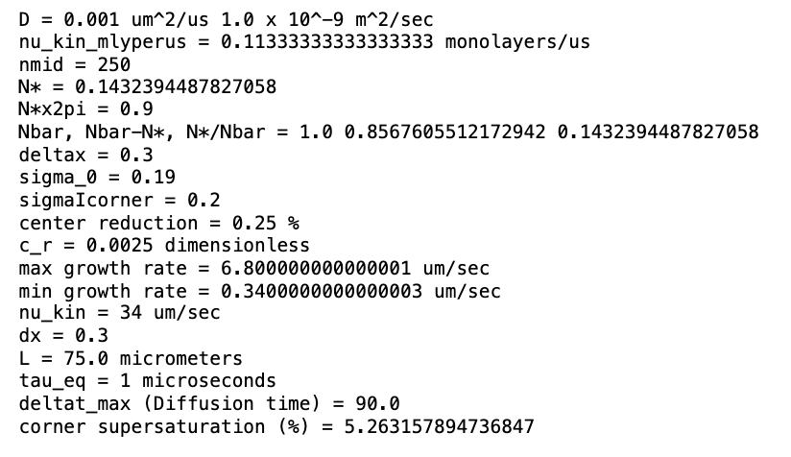

**Run 3**. Can a **slower ice/liquid equilibration** avoid the instability shown in Run 1? The answer appears to be Yes, when (as below) we increase the equilibration time constant to . However, there’s no steady state.

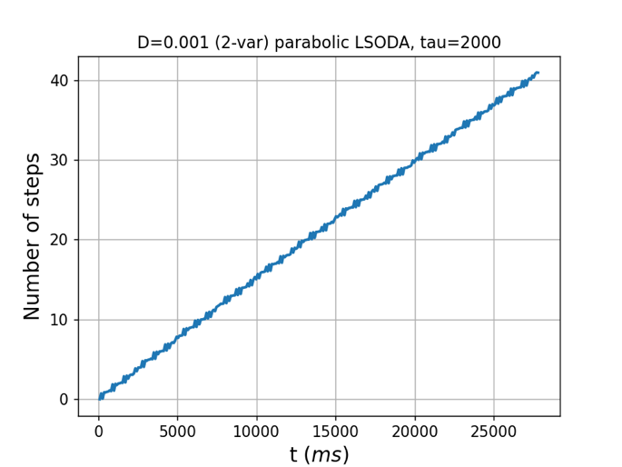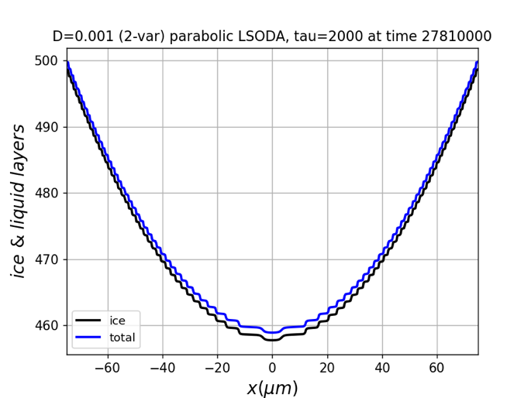

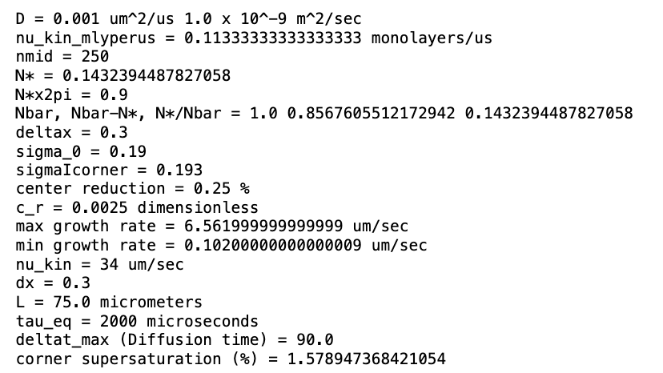

**Run 4**. Does **slower diffusion** increase the number of layers (equivalently, reduce ) seen in Run 2? The answer is Yes, as shown below.

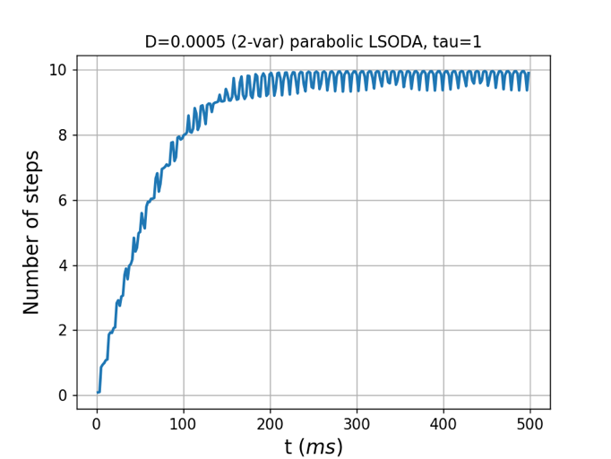 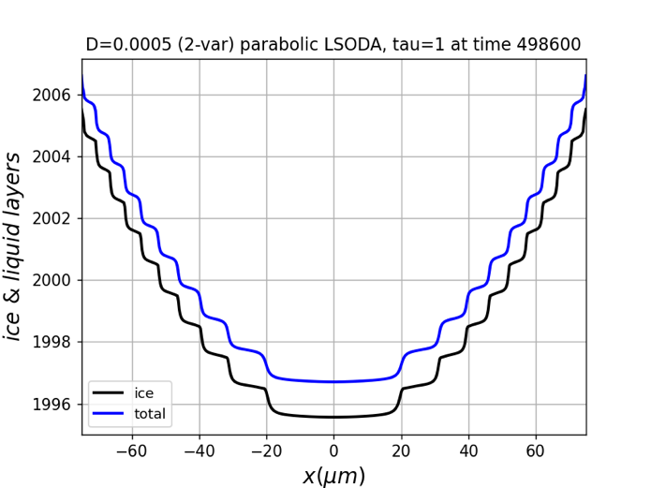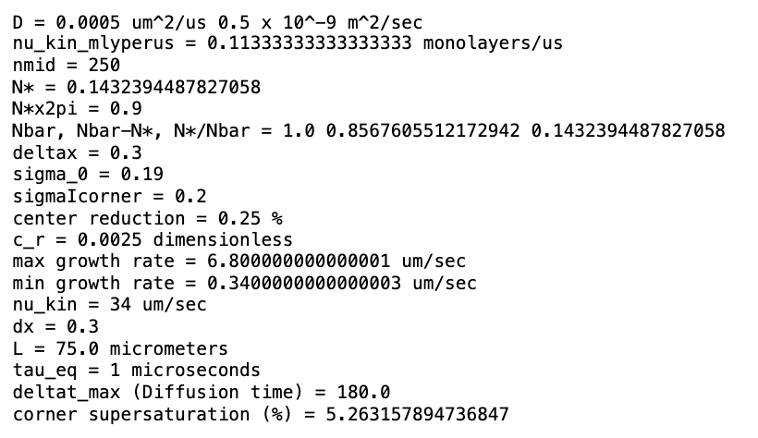

**Run 5**. Does the **slower diffusion** seen in Runs 2, 4 (and this one) increase the number of layers/reduce proportionally to ? The answer is Yes, as shown below.

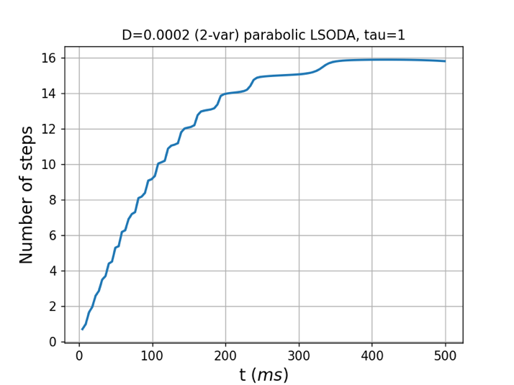 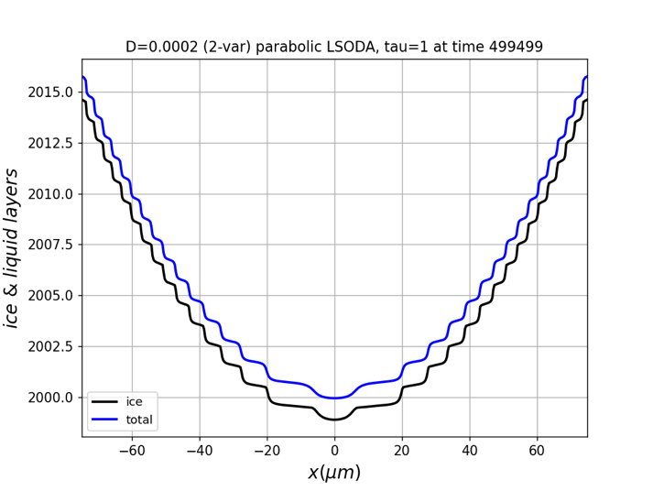

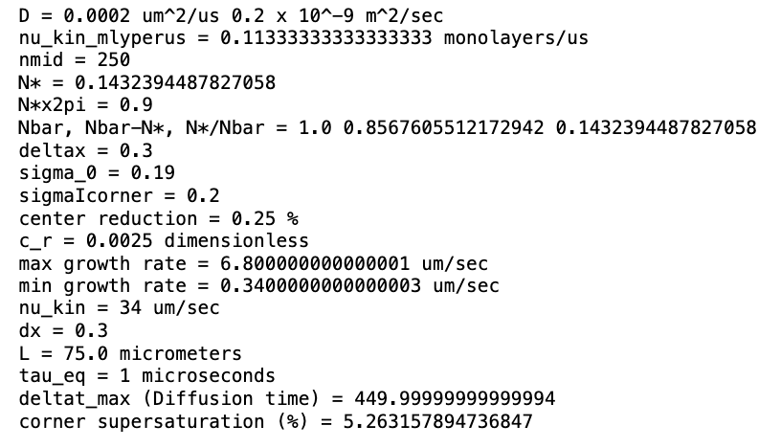

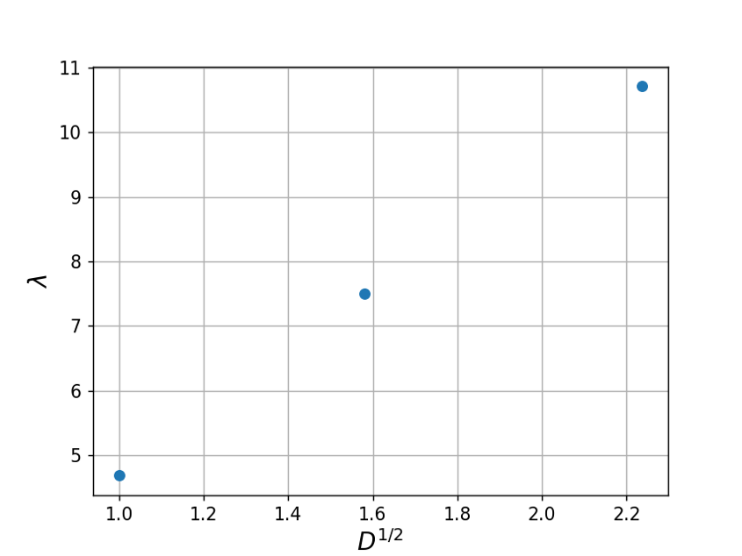

(Here, the x-axis is relative to )

**Run 6**. Exploring more instability. If we duplicate Run 1, but with a slightly smaller supersaturation of , we should get instability and no steady-state. But what is the vertical relief? The answer below shows that we can get hundreds of monolayers, corresponding to and growing. This would appear as a slight indentation in the middle of the facet –no different from the stable V-shaped profiles in Run 2 – Run 5.

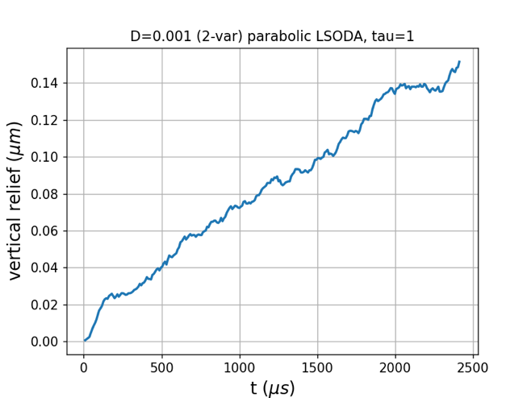

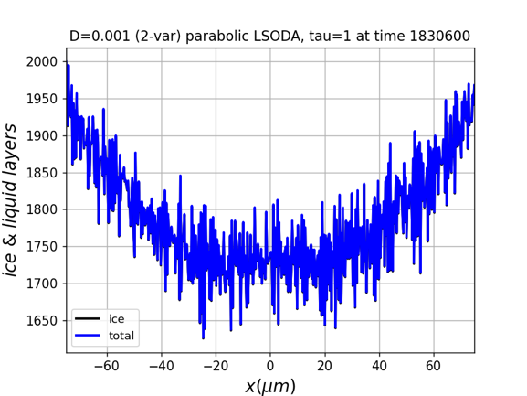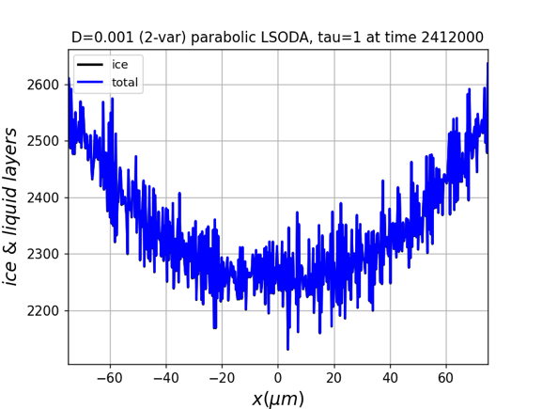

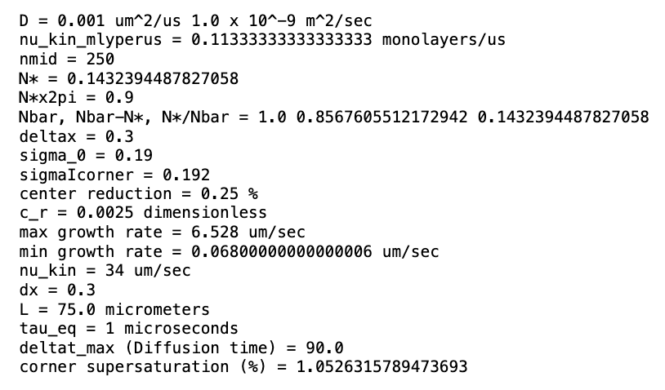

**Run 7**. Exploring more instability. If we duplicate Run 1, but with a yet slightly smaller supersaturation of , we reach a dip of (and growing).

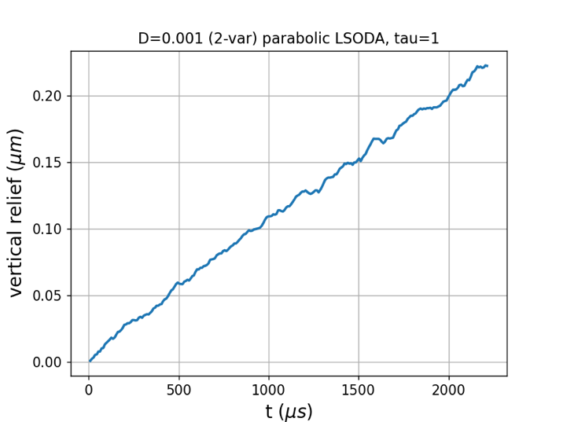 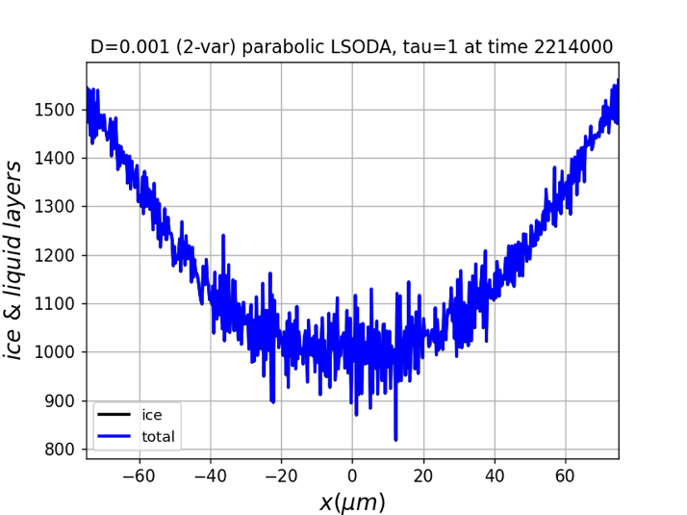

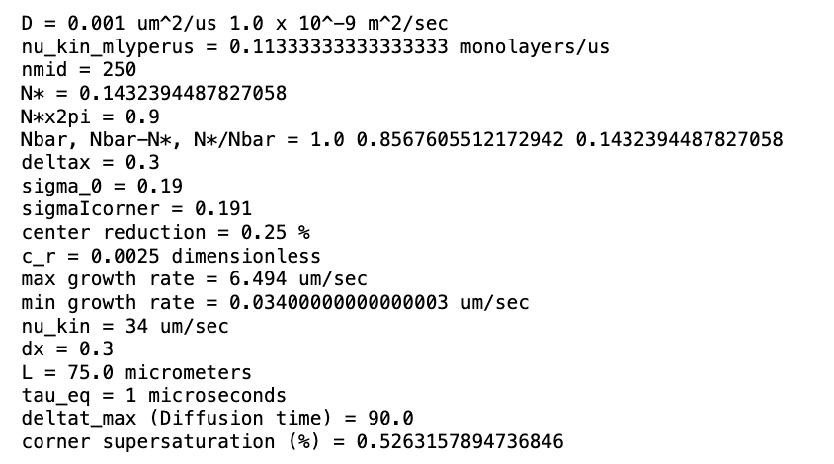

**Run 8**. Exploring more instability. This is the same as Run 1, just longer. We reach a dip of (and growing).

